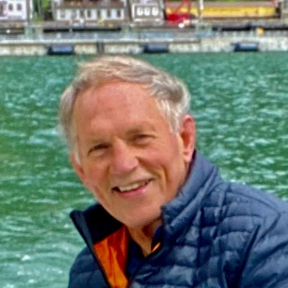
CAPT ED PAGE, USCG (RET)
Executive Director, Alaska Marine Exchange, Juneau Alaska.
Captain Page is a 1972 graduate of the U.S. Coast Guard Academy and served as a commissioned officer for 29 years. He sailed Atlantic, Pacific and Alaska waters and served in various marine safety assignments on the West Coast, Alaska and Japan. Later in his career he served as Captain of the Port and Group Commander for the Los Angeles/Long Beach region and as the Chief of Marine Safety and Environmental Protection for the Coast Guard Pacific Area. He retired from the Coast Guard in 2001 to establish the Marine Exchange of Alaska. Ed has lived in Alaska for 30 years and is an avid kayaker, sailor, skier and hiker.

